# ASSIGNMENT 2

1. Inset and Update with Integrity: Create a 'students' table with constraints (NOT NULL, UNIQUE). Insert 5 records. Then, update a student's marks ensuring data integrity is maintained.

CREATE DATABASE ASSIGNMENT2;

USE ASSIGNMENT2;

CREATE TABLE STUDENTS(

studentID INT PRIMARY KEY AUTO_INCREMENT,

Name varchar(30) NOT NULL,

Marks INT NOT NULL,

email VARCHAR(100) UNIQUE

);

INSERT INTO STUDENTS VALUES

(1,'Anas',90, 'anas@gmail.com'),

(2,'Jothi',80,'jothi@gmail.com'),

(3,'Durga',85,'durga@gmail.com'),

(4,'Yuva',75,'yuva@gmail.com'),

(5,'Sathya',85,'sathya@gmail.com');

UPDATE Students SET Marks = 95 WHERE studentID=3;

SELECT * FROM STUDENTS;

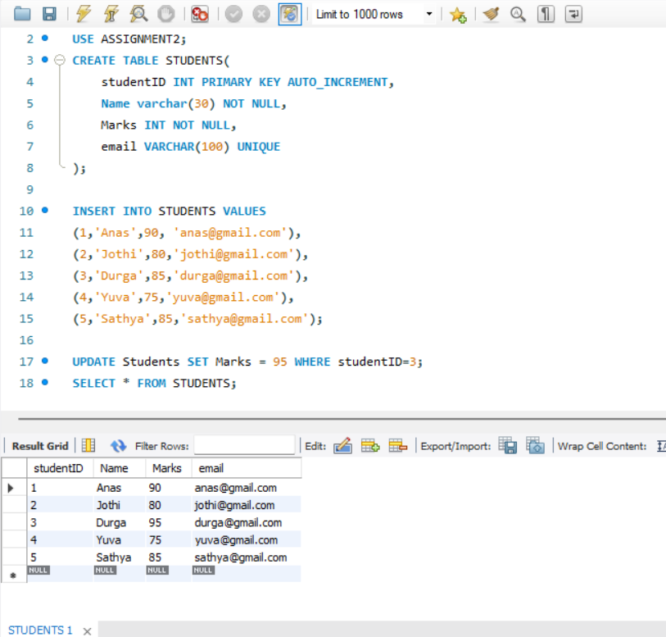

2. String Function Challenge: Given a 'customers' table with a 'full_name' column, write a query to display: - First name - Last name - Length of each name

CREATE TABLE CUSTOMERS(

fullname varchar(50));

INSERT INTO CUSTOMERS VALUES

('Anas Muhammad'),

('Abay Ragav'),

('Afeef Abdulla'),

('Deepak t'),

('Prem Kumar'),

('Loganathan');

SELECT

fullname,

SUBSTRING_INDEX(fullname, ' ', 1) AS first_name,

SUBSTRING_INDEX(fullname, ' ', -1) AS last_name,

LENGTH(fullname) AS name_length

FROM CUSTOMERS;

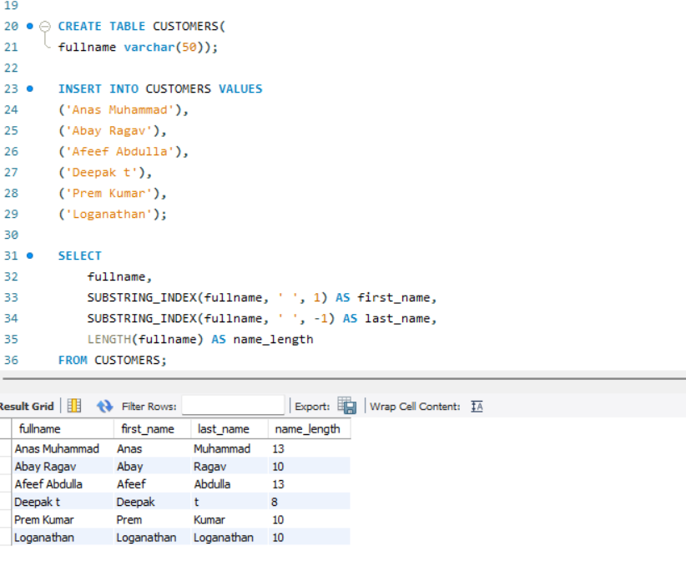

3. Date Function Usage: From a 'sales' table with a 'sale_date' column, write a query to: - Extract the month name and year - Display how many days ago the sale happened

CREATE TABLE sales (

sale_id INT PRIMARY KEY,

sale_date DATE

);

INSERT INTO sales VALUES

(1, '2024-05-10'),

(2, '2023-11-15'),

(3, '2025-01-01'),

(4, CURDATE());

SELECT

sale_date,

MONTHNAME(sale_date) AS month_name,

YEAR(sale_date) AS year,

DATEDIFF(CURDATE(), sale_date) AS days_ago

FROM sales;

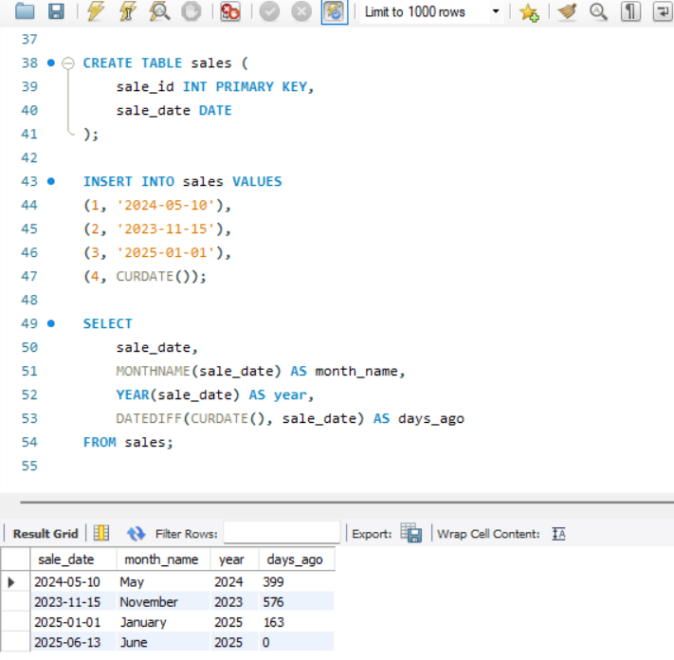

4. Mathematical Functions on Salary: In an 'employees' table, calculate: - Salary after a 10% hike - Round the salary to the nearest hundred

CREATE TABLE employees (

emp_id INT PRIMARY KEY,

name VARCHAR(50),

salary DECIMAL(10,2)

);

INSERT INTO employees VALUES

(1, 'Anas', 52000),

(2, 'Sneha', 65000),

(3, 'Ravi', 45000);

SELECT * FROM EMPLOYEES;

SELECT

name,

salary,

ROUND(salary * 1.10, 2) AS salary_after_hike,

ROUND(salary, -2) AS rounded_salary

FROM employees;

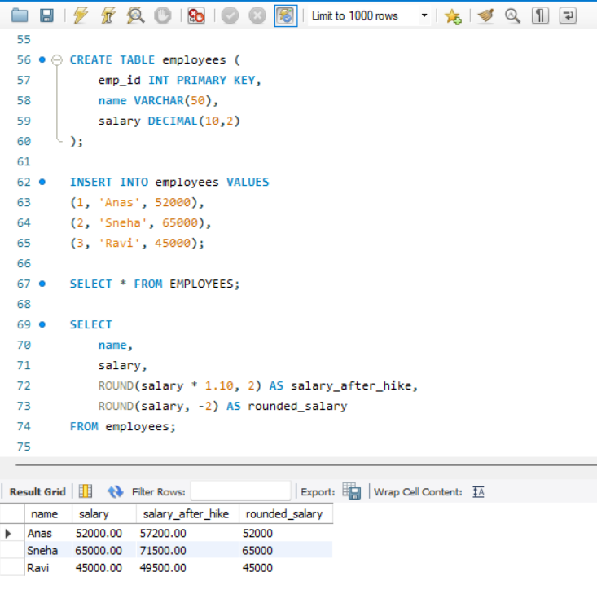

5. System Function Check: Retrieve: - Current date and time - Database name and logged-in user

SELECT

NOW() AS current_datetime,

CURDATE() AS `current_date`,

DATABASE() AS `current_database`,

USER() AS `current_user`;

-- used bacticks for forced evaluation.

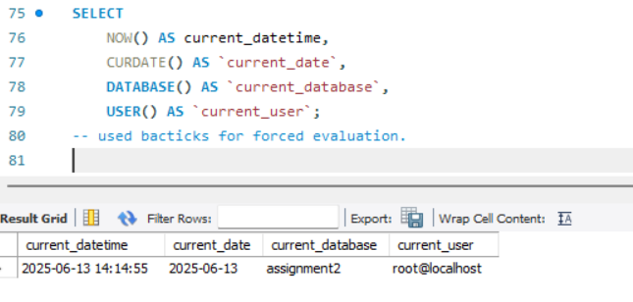

6. Demo: Custom Result Set: From the 'products' table, write a query that: - Returns product name in uppercase - Replaces any NULL prices with 'Not Available'

CREATE TABLE products (

product_id INT PRIMARY KEY,

product_name VARCHAR(100),

price DECIMAL(10,2)

);

-- inserting values without null

INSERT INTO products VALUES

(1, 'Laptop', 50000),

(2, 'Tablet', 18000);

-- inserting value with null

INSERT INTO products (product_id,product_name) values (3,'Phone');

SELECT * FROM products;

SELECT

UPPER(product_name) AS product_name,

IFNULL(price, 'Not Available') AS display_price

FROM products;

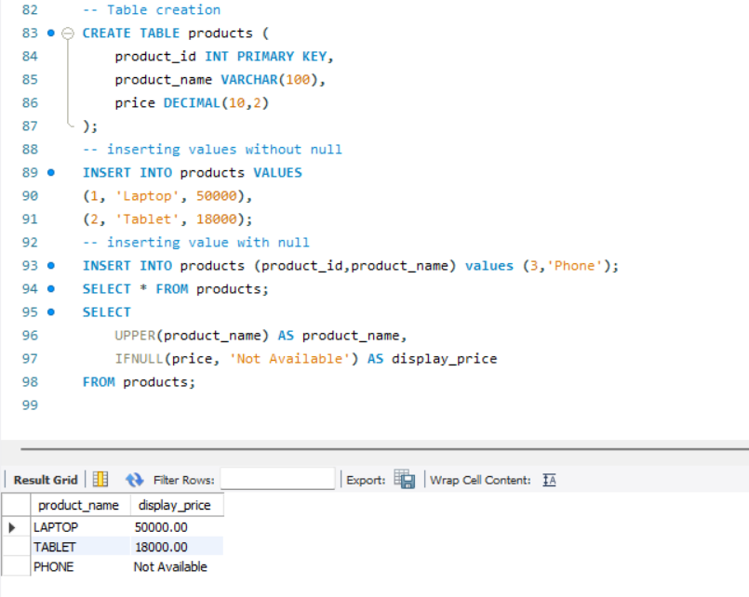

7. Aggregate Functions Practice: From a 'transactions' table, get: - Total sales - Average sale value - Maximum and minimum sale on a single transaction

CREATE TABLE transactions (

trans_id INT PRIMARY KEY,

sale_amount DECIMAL(10,2)

);

INSERT INTO transactions VALUES

(1, 200),

(2, 450),

(3, 150),

(4, 700);

SELECT

SUM(sale_amount) AS total_sales,

AVG(sale_amount) AS avg_sale,

MAX(sale_amount) AS max_sale,

MIN(sale_amount) AS min_sale

FROM transactions;

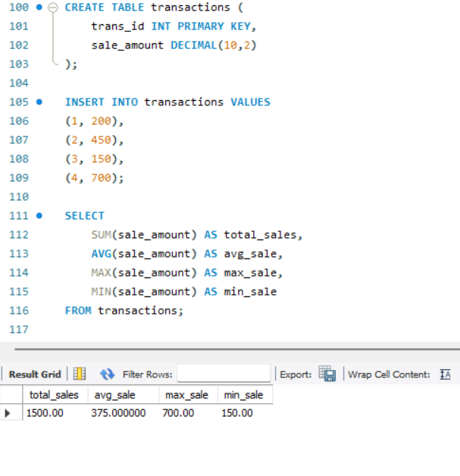

8. Grouping with Aggregation: From a 'sales' table: - Group by product category - Show total sales and number of transactions in each category

CREATE TABLE sales2 (

sale2_id INT PRIMARY KEY,

product_category VARCHAR(50),

sale_amount DECIMAL(10,2)

);

INSERT INTO sales2 VALUES

(1, 'Electronics', 1000),

(2, 'Electronics', 2000),

(3, 'Clothing', 800),

(4, 'Clothing', 1200);

SELECT

product_category,

SUM(sale_amount) AS total_sales,

COUNT(*) AS transaction_count

FROM sales2

GROUP BY product_category;

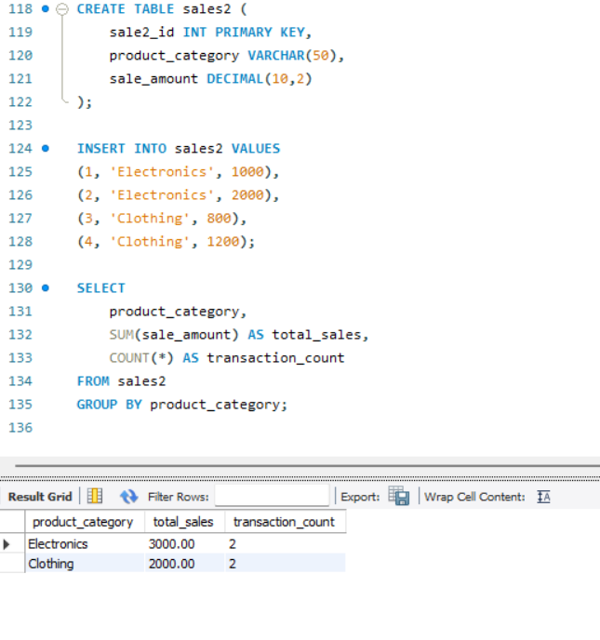

9. Inner Join for Orders and Customers: Join 'orders' and 'customers' to show: - Customer name - Order amount - Only for customers who made orders

ALTER TABLE CUSTOMERS

ADD COLUMN CustomerId INT PRIMARY KEY AUTO_INCREMENT;

SELECT * FROM CUSTOMERS;

ALTER TABLE CUSTOMERS

MODIFY CustomerId INT FIRST;

SELECT*FROM CUSTOMERS;

CREATE TABLE orders (

order_id INT PRIMARY KEY,

customerId INT,

order_amount DECIMAL(10,2),

FOREIGN KEY (customerId) REFERENCES CUSTOMERS(CustomerId)

);

INSERT INTO orders VALUES

(101,1,1200),

(102,2,800),

(103,3,600),

(104,4,1200),

(105,5,1800),

(106,6,1200)

;

SELECT

c.fullname AS customer_name,

o.order_amount

FROM customers c

INNER JOIN orders o ON c.customerId = o.customerId;

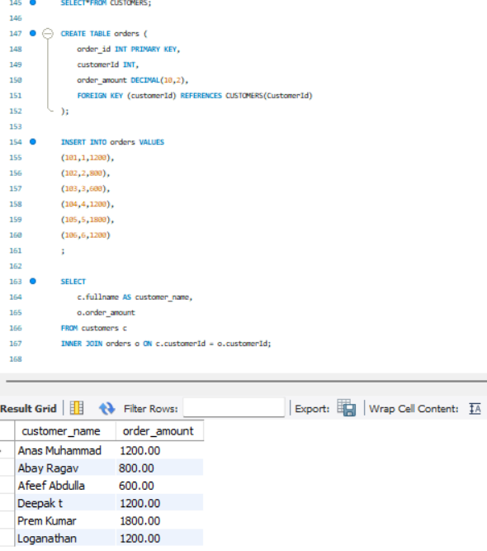

10. Left Join for Products with or without Orders: Show all products with: - Their order details (if available) - Use LEFT JOIN

SELECT * FROM PRODUCTS;

ALTER TABLE ORDERS

ADD COLUMN Product_id INT;

ALTER TABLE ORDERS

ADD FOREIGN KEY (product_id) REFERENCES PRODUCTS(product_id);

SELECT

p.product_name,

o.order_id,

o.order_amount

FROM products p

LEFT JOIN orders o ON p.product_id = o.product_id;

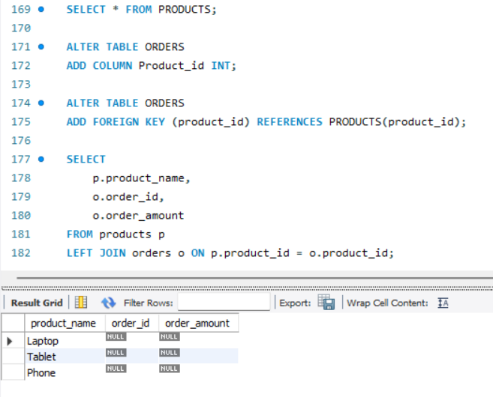

11. Right Join for Customer Contacts: Use a RIGHT JOIN between 'contacts' and 'customers' to display: - All customers, even if they don't have contact info

SELECT * FROM CUSTOMERS;

CREATE TABLE contacts (

contact_id INT PRIMARY KEY,

customerId INT,

phone VARCHAR(15),

email VARCHAR(50),

FOREIGN KEY (customerId) REFERENCES customers(customerId)

);

INSERT INTO contacts VALUES

(1, 1, '9999999999', 'anas@gmail.com'),

(2,2,'2020202020','abay@gmail.com'),

(3,3,'303030303030','afeef@gmail.com'),

(4,4,'4040404040','deepak@gmail.com');

SELECT

c.fullname,

con.phone,

con.email

FROM contacts con

RIGHT JOIN customers c ON con.customerid = c.customerid;

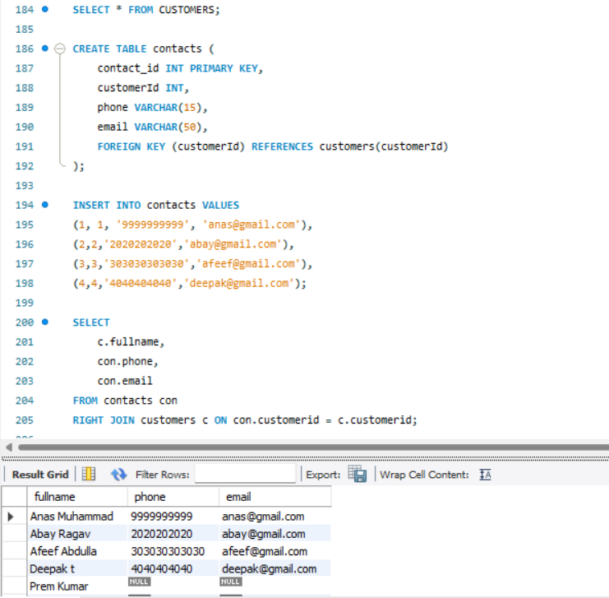

12. Full Outer Join for Suppliers and Products: Use a FULL OUTER JOIN to list: - All suppliers and products - Match supplier to product, or show NULLs where not available

CREATE TABLE suppliers (

supplier_id INT PRIMARY KEY,

supplier_name VARCHAR(50)

);

INSERT INTO suppliers VALUES

(1, 'Dell'),

(2, 'HP');

SELECT s.supplier_name, p.product_name

FROM suppliers s

LEFT JOIN products p ON s.supplier_id = p.product_id

UNION

SELECT s.supplier_name, p.product_name

FROM suppliers s

RIGHT JOIN products p ON s.supplier_id = p.product_id;

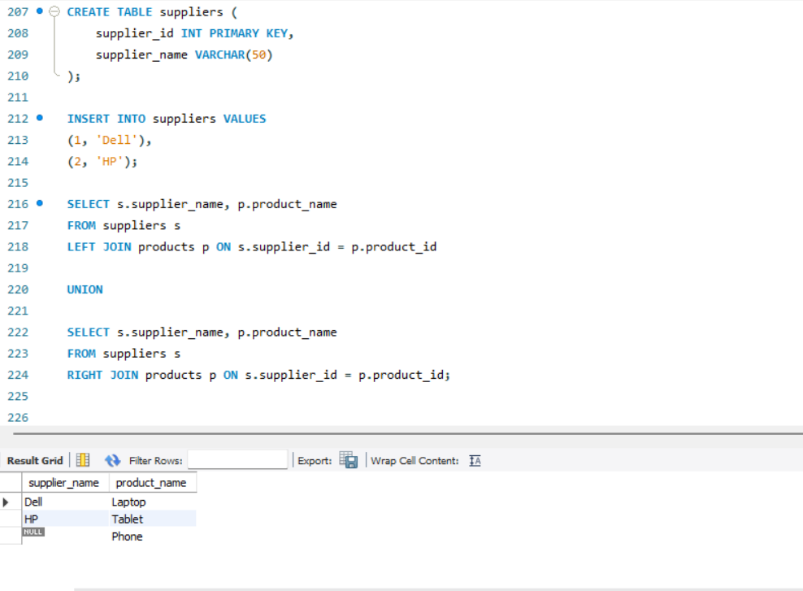

13. Cross Join for Offers: Suppose you have tables 'products' and 'offers'. Write a CROSS JOIN to show: - All possible combinations of products and offers

CREATE TABLE offers (

offer_id INT PRIMARY KEY,

offer_name VARCHAR(50)

);

INSERT INTO offers VALUES

(1, 'Summer Sale'),

(2, 'New Year Offer');

SELECT

p.product_name,

o.offer_name

FROM products p

CROSS JOIN offers o;

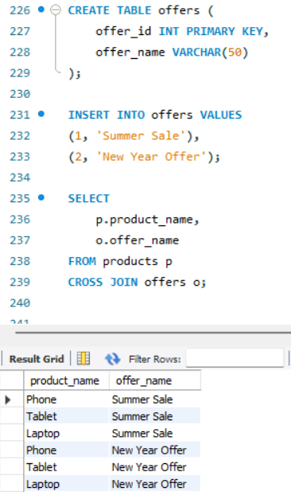

14. Join with Aggregation: Join 'orders' and 'products', then group by product category and: - Show total quantity sold and average price per category

ALTER TABLE products ADD COLUMN category VARCHAR(50);

UPDATE products SET category = 'Electronics' WHERE product_id IN (1,3);

UPDATE products SET category = 'Gadgets' WHERE product_id = 2;

ALTER TABLE orders ADD COLUMN quantity INT;

UPDATE orders SET quantity = 2 WHERE order_id = 1;

UPDATE orders SET quantity = 1 WHERE order_id = 2;

SELECT

p.category,

SUM(o.quantity) AS total_quantity,

AVG(p.price) AS avg_price

FROM orders o

JOIN products p ON o.product_id = p.product_id

GROUP BY p.category;

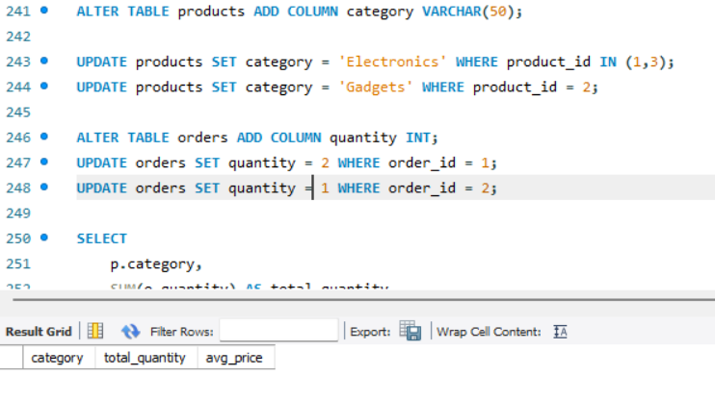

15. Demo: Join with Grouping and Filter: Join 'students' and 'marks' tables. Display: - Student name - Average marks - Filter to show only students with average marks > 75

CREATE TABLE marks (

mark_id INT PRIMARY KEY,

student_id INT,

marks INT

);

INSERT INTO marks VALUES (1, 1, 85), (2, 2, 75), (3, 3, 95), (4, 3, 90), (5, 4, 60);

SELECT * FROM STUDENTS;

SELECT * FROM MARKS;

ALTER TABLE MARKS

CHANGE student_id studentid int;

SELECT

s.name,

AVG(m.marks) AS avg_marks

FROM students s

JOIN marks m ON s.studentid = m.studentid

GROUP BY s.name

HAVING AVG(m.marks) > 75;

